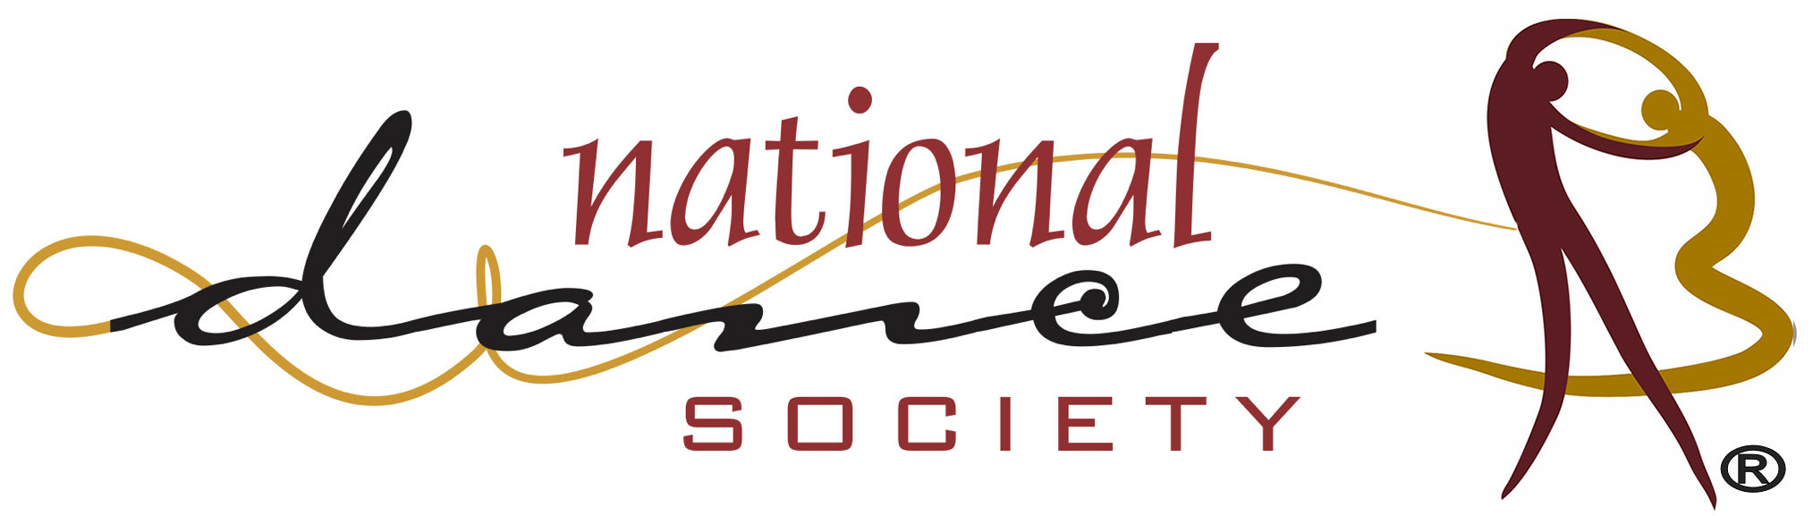 CALL FOR NOMINATIONS - OFFICERS

Two of the seven purposes of the National Dance Society are to:
- promote personal leadership skills and strategies that can strengthen dance education within schools, the community, the state, and nationwide,
- encourage professional involvement in education and dance education and recognize excellence among professional and future dance educators.
Help us identify individuals with the characteristics and skills that can provide leadership in moving forward dance and dance education nationwide.

QUALIFICATIONS FOR OFFICES: 1) be a professional member of the NDS for at least 3 consecutive years prior to nomination, 2) have a background and interest in any discipline supported by NDS, 3) have demonstrated service to the profession at the local, state, national levels, and/or international levels, and 4) be ready to assume the duties/responsibilities of the office as prescribed in the organization’s bylaws and operating procedures.

The 2025 nominees will be for the following positions: 1) president-elect serves a 3-year term (as president-elect, president, and past-president) and the Member-at-Large (MAL) positions are a 2-year term. Any member of NDS may submit nominees for offices. An individual may nominate members for more than one position.

CHECK THE APPROPRIATE OFFICE

___ President Elect ___Member-at-Large

I Nominate: Name _________________________________________________________________
Address _______________________________________________________________
City/State/Zip __________________________________________________________
Phone (Home)_____________________ (Work)_______________________________
(E-Mail) _______________________________________________________________

Nominated By: Name of Person Submitting
Address _______________________________________________________________
City/State/Zip __________________________________________________________
Phone (Home)_____________________ (Work)_______________________________
(E-Mail) _______________________________________________________________

DEADLINE – December 15, 2024

Hand to: Fran Anthony Meyer, Executive Director, at the 2024 South Carolina conference OR

Send to: Fran Anthony Meyer, Executive Director: fameyerdance@aol.com or
852 Lincoln Drive, Fredericksburg, VA 22407

After the nominee’s membership qualifications are verified, the nomination will be submitted to the Nominations Committee Chair for the Committee to vet all nominees and select candidates for the annual election of officers. Questions about the officer nomination may be sent to the email above or call 540-642-1041. Please leave a message if there is no answer.

